October 04, 2024

**!F RELEAES HIS DEBUT SINGLE „HOME”**

**First Single is now available on all platforms**

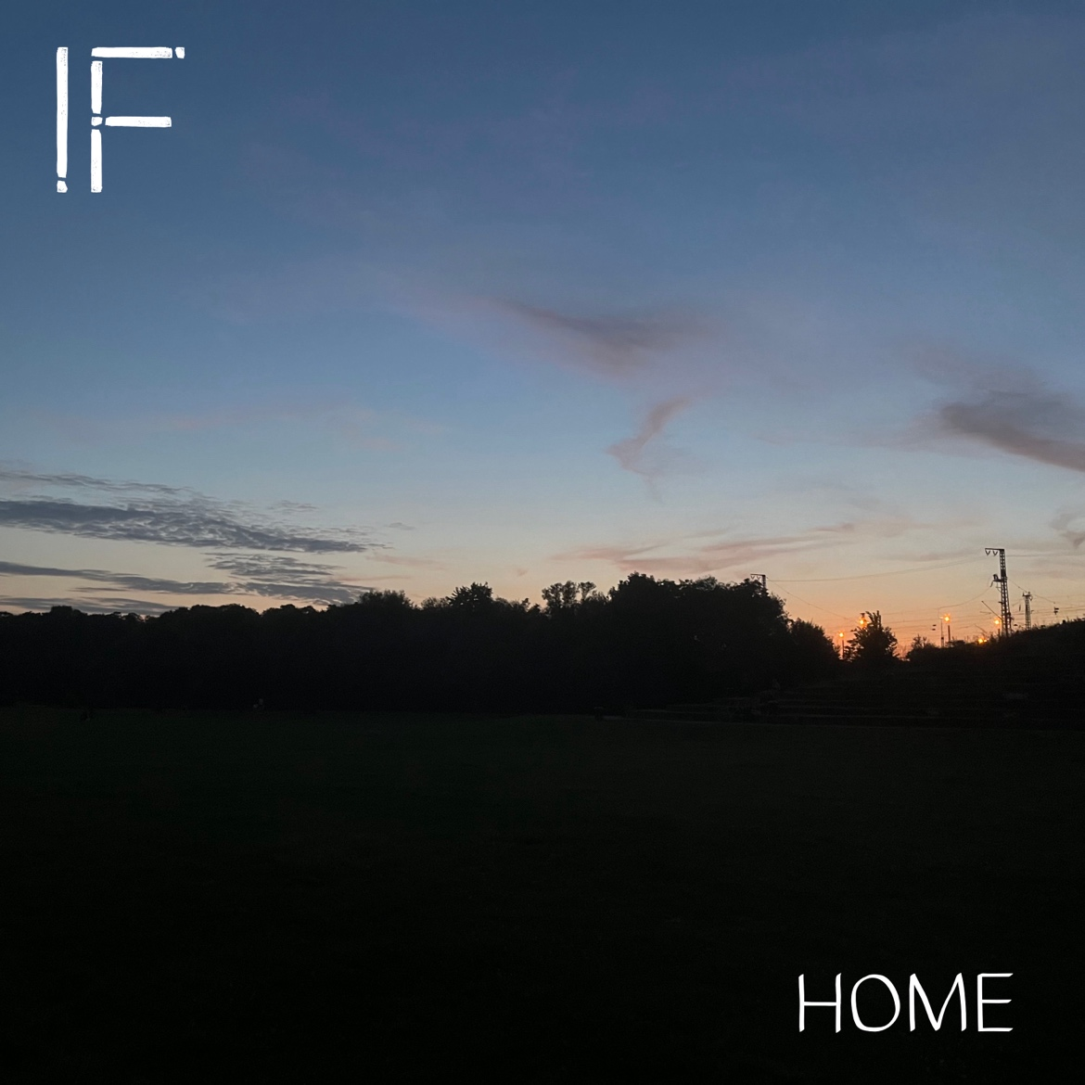

[DOWNLOAD HIGH-RESOLUTION IMAGES](https://www.ifmusicofficial.com/press/)

STREAM “HOME” [HERE](https://listen.music-hub.com/85WH6Z)

!F. I‘m writing Songs for Lonely People and Overthinkers.

!F’s debut release, Home, is a poetic meditation about arriving and letting go at the same time. It brings feelings of welcome and letting go at the same time with a hint of jazz and a melancholic mood. It was the first thing that poured out of me on my last holiday. I was thinking of a good friend, that I’ve lost contact to a little bit and at the same time I had this warm feeling of arriving, which creates its special atmosphere.

!F is a minimalistic singer songwriter who blends catchy melodies with personal, poetic, and conversational lyrics about love, loneliness and self-doubt. Influenced by pop, rock and folk, the music can sound warm and welcoming, but also melancholic or even raw at times. While it can be playful with intimate and quiet or expressive and louder moments, it‘s always focused on emotion rather than virtuosity.



[DOWNLOAD HIGH-RESOLUTION IMAGES](https://www.ifmusicofficial.com/press/)

Connect with !F

[Website](https://www.ifmusicofficial.com/) [Instagram](https://www.instagram.com/followifhere/) [TikTok](https://www.tiktok.com/@followifhere) [X](https://x.com/followifhere) [Facebook](https://www.facebook.com/followifhere) [Snapchat](https://www.snapchat.com/add/followifhere) [YouTube](https://www.youtube.com/@followifhere) [Spotify](https://open.spotify.com/intl-de/artist/5Jj3bz4CqVC1t33LiCAKbZ?si=bRDXGkYsTfSqm0H3dWv9Ew) [Apple Music](https://music.apple.com/de/artist/f/1770039099)